UML Diagrams

UML Use Case Diagram
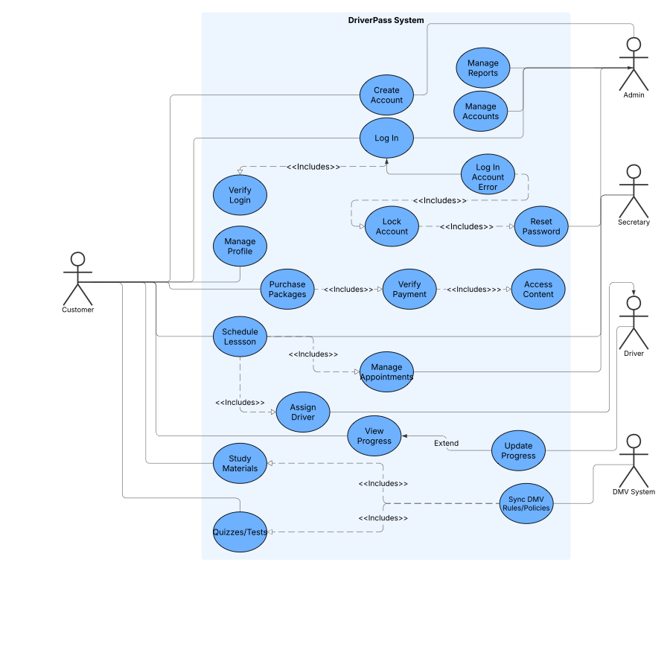

UML Activity Diagrams
Case One: Schedule Driving Lesson
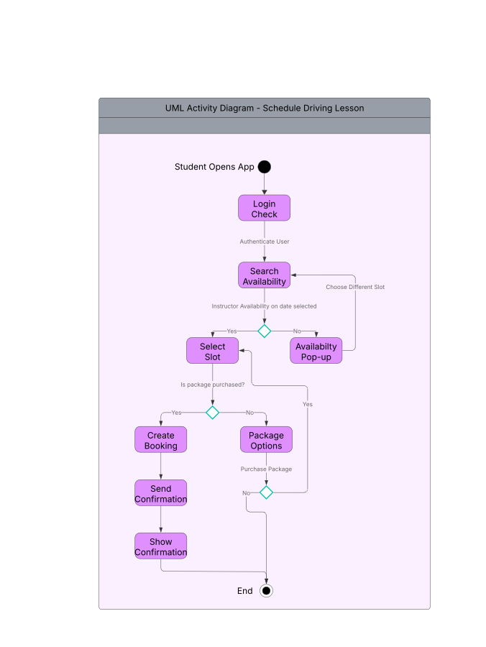

Case Two: Take Practice Test
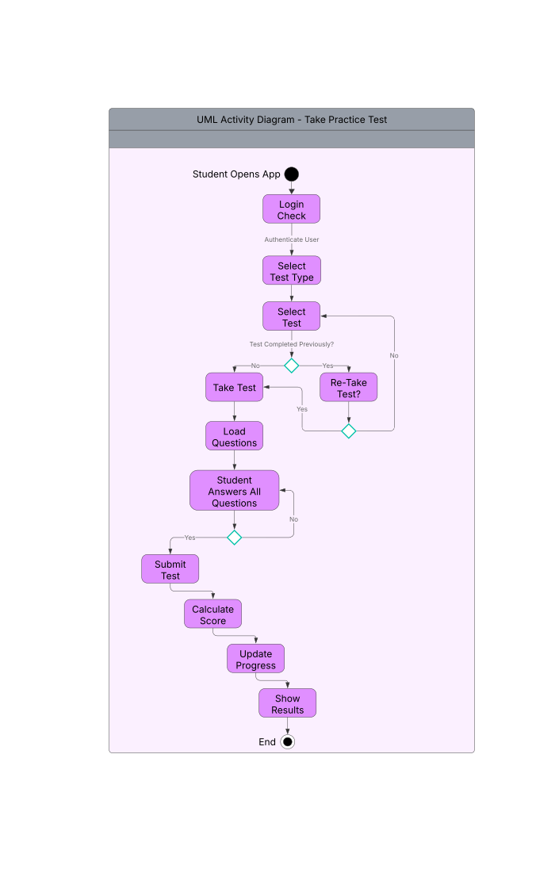

UML Sequence Diagram
Schedule Driving Lesson
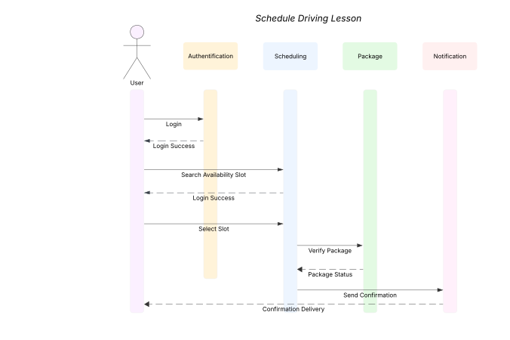

UML Class Diagram
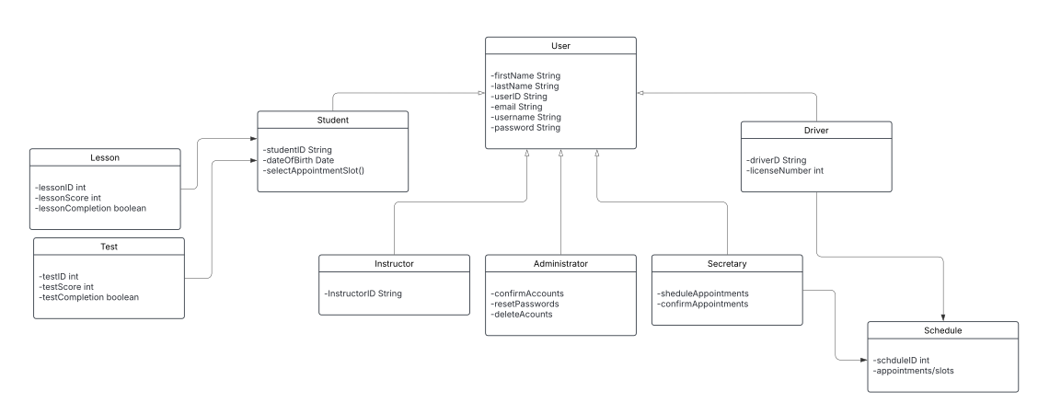

Technical Requirements

Hardware Requirements
- A reliable server or hosting platform to run the DriverPass system
- A stable internet connection for all users
- Adequate storage space for lessons, user accounts, and test data
- Computers and mobile devices for users to access the website
- A firewall to help protect the server and prevent unauthorized access

Software Requirements
- A web browser such as Google Chrome, Firefox, or Safari for users
- A web server to host the website
- A database management system such as SQL Server or MySQL
- Backup software to protect data in case of system failure
- Security software to help detect and stop viruses or malware

System Features
- User login and password protection for all accounts
- Role-based permissions for students, instructors, and administrators
- The ability for students to schedule driving lessons and take practice tests
- Account management tools like password resets and profile updates
- Automatic confirmation messages or emails after bookings or test submissions

